XG3P Camera Glasses

User Manual

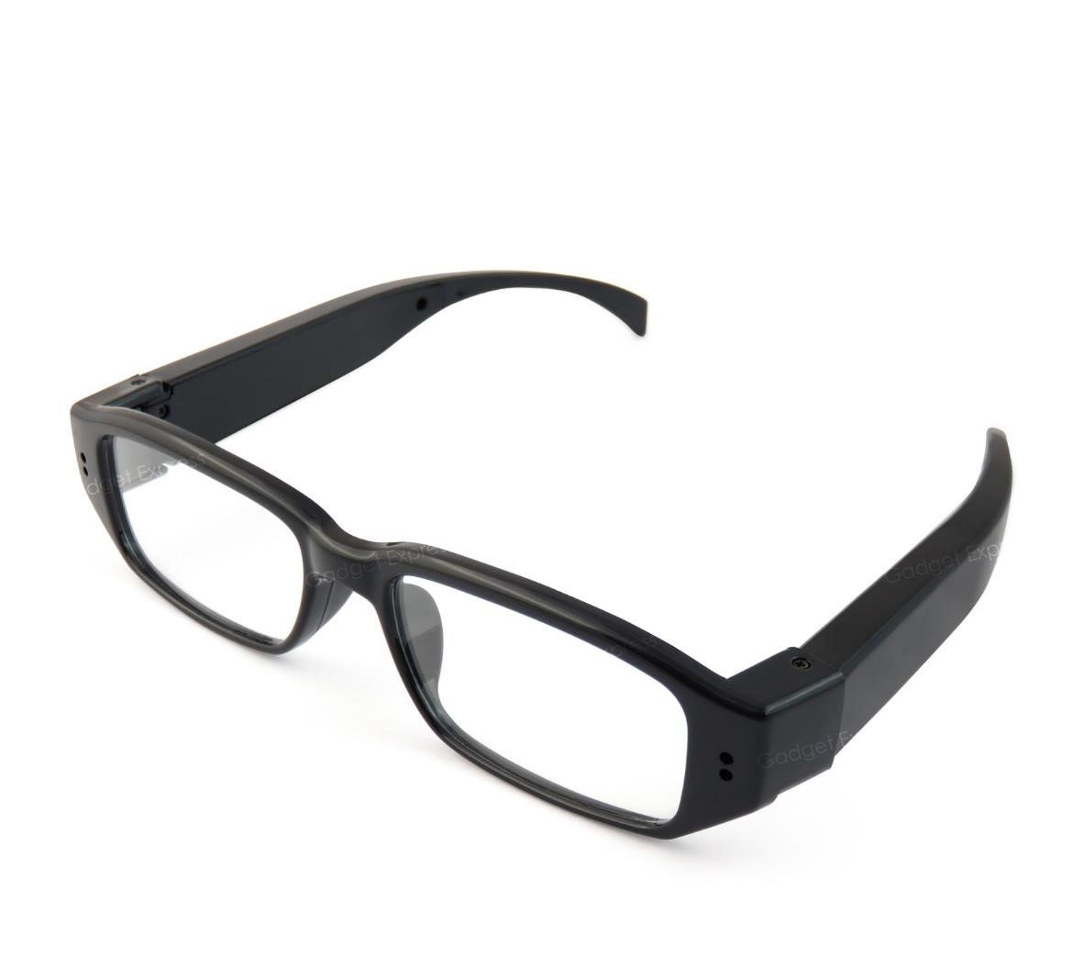

Contents
Package Contents 2
Before You Start 2
Overview & Basic Setup 3
Battery and Charging 3
Inserting the Memory Card 3
Reading the Memory Card 4
Operation Instructions 4
Turn the Glasses On and Off 4
Recording a Video 4
Taking a Picture 4
Timestamp Edit 5

Package Contents
- XG3P Camera Glasses
- USB Cable

Before You Start
Make sure you have charged the device for a minimum of 4 hours prior to use.
It is recommended that the first charge is at least 12 hours to condition the battery and help provide the best battery life for as long as possible.
You must insert a Micro SD memory card before using this device otherwise it will not work.

Overview & Basic Setup

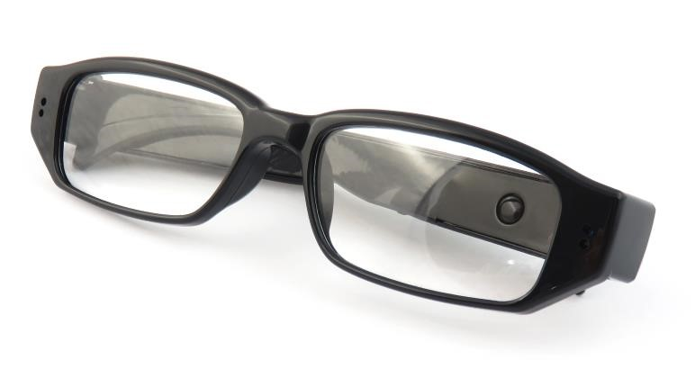

Figure
1

MFB
(
multifunction
button)

LED Indicator

Battery and Charging
Supplied with the glasses is a USB cable which enables you to charge the internal battery. This can be done via a computer or a USB mains charger. Whilst on charge, the LED indicator will flash red.

Inserting the Memory Card
For the glasses to record any footage you must insert a Micro SD card; you can use any Micro SD card from 4GB up to a maximum of 32GB. If you need a Micro SD card then take a look here: www.wecostless.co.uk > electronics > memory cards
To insert a memory card into the device, find the card slot on the side of the arm. Insert the memory card with the contacts facing down and push until it clicks into place.
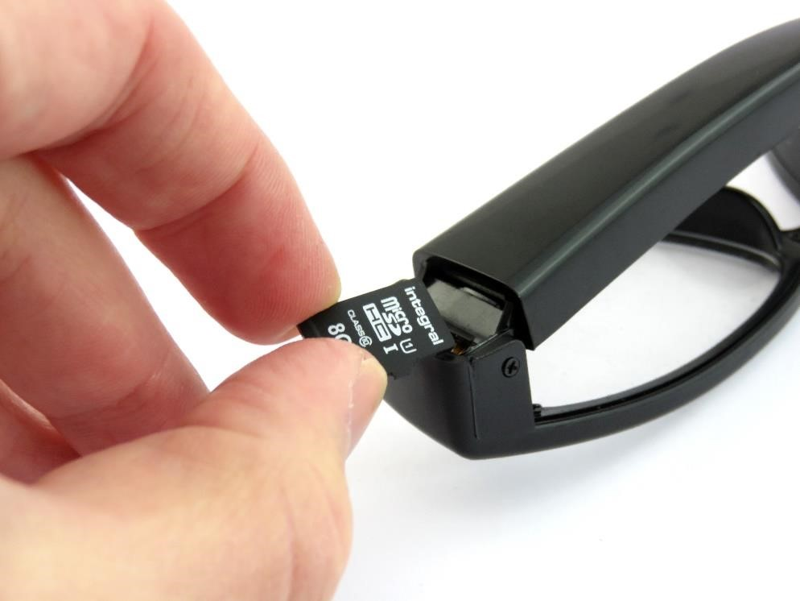
Figure 2

Reading the Memory Card
Connect the glasses via the included USB cable to a USB port on your desktop or laptop computer.
You may see a message in the system tray about “Installing Device Drivers”. You will then see an “Autoplay” window open which will allow you to access the inserted memory card. If the autoplay window does not open it may be due to your settings. You can still access the memory card by going to “My Computer” and then double clicking the appropriate removable device.
If you are unsure which device is your card then do the following. Open the “My Computer” window and see what it there, plug in the glasses and you will see the removable device appear in the window. Please allow up to 30 seconds for the device to appear.

Operation Instructions

Turn the Glasses On and Off
Press and hold MFB for 3 seconds and let go. At first the LEDs will show both blue and red for around 2 seconds before turning solid red and this is Standby mode.
When the glasses are in standby mode, press and hold MFB for 5 seconds. The LED goes out and the glasses are now off.

Recording a Video
When the glasses are in standby mode, press and hold MFB for 3-4 seconds and let go. The LED will flash 3 times and then go out – the glasses are now recording a video. Press the button again to stop recording. The LED will turn red – the glasses are now back in standby mode.

Taking a Picture
When the glasses are in standby mode, quickly press the MFB. The LED will go blue for a moment
and then come back on red – this indicates the glasses have taken a picture.

Timestamp Edit

You may need to update the timestamp shown on the glasses images and videos.
To do this you will need to create or edit a Text file with the date and time.
- Plug the glasses into your computer by using a USB cable.
- It will appear as a removable disk.
- Open the removable disk; you might have some folders and a text file called “time.txt” already there.
- If you already have the text file then skip to Step 7.
- Right click in the white space and a menu will appear (Figure 3), move down to “New” and select “Text Document”.

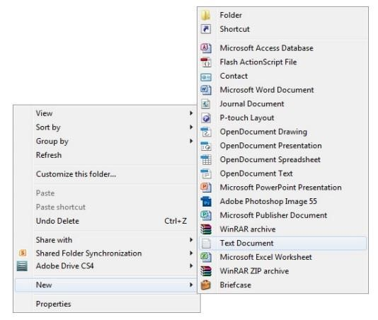
Figure 3

- A new Text document will appear (Figure 4) and give you the option to name it, call it “time”.

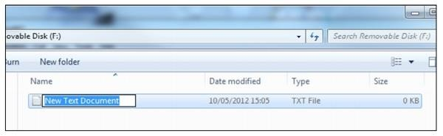
Figure 4
- Open this time file and write the date and time in the following format:
2017/05/17 09:46:11
- Save and close the file.
- Unplug the glasses from the computer and turn them on. The time is now updated.

